Python Django Tutorial 2021

# Setup

1. pip install virtualenv
2. virtualenv dj_ds
3. source dj_ds/bin/activate
4. pip install django
5. django-admin startproject reports_proj
6. python manage.py migrate
7. python manage.py createsuperuser (dongpv/123456a@)
8. python manage.py startapp sales
9. python manage.py startapp reports
10. python manage.py startapp profiles
11. python manage.py startapp products
12. python manage.py startapp customers
13. python manage.py runserver

# Setup 2

1. pip install pillow django-crispy-forms matplotlib seaborn pandas xhtml2pdf

# Setup 3

1. Setup apps

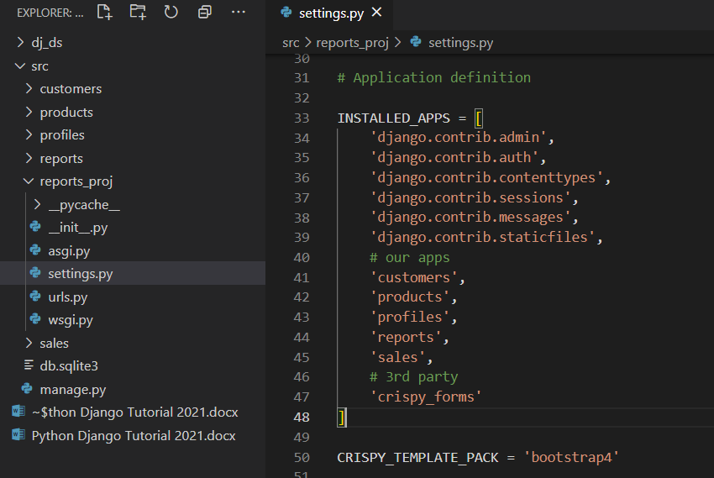

1. Add templates file

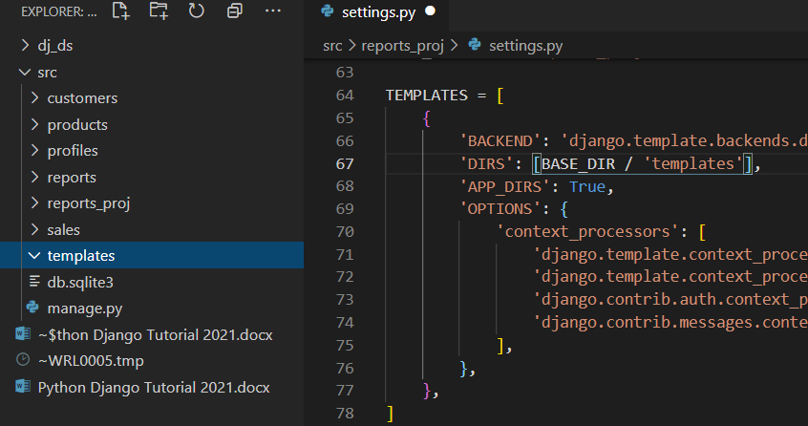

1. Add media and static files

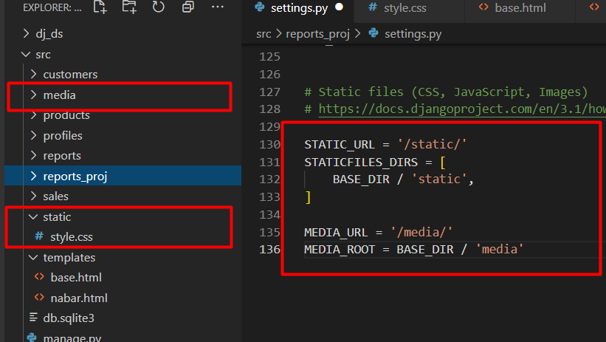

1. Adding static_url and media_url to urls.py file

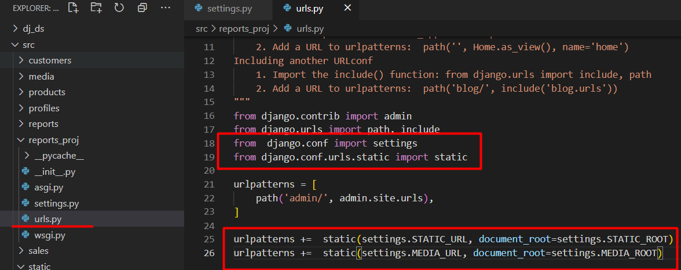

1. Add base.html code